**PLEXR GROUP CHAT**

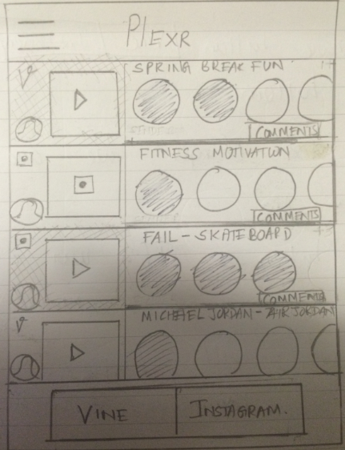

Home screen

This is the new home screen of Plexr. It is different from the current home screen in many aspects. The main difference is, the chat is “content focused” as opposed to “user focused” in the current version.

When a user shares content with a group of friends, a new chat window will be created in the home screen. The chat window preview on the home screen will have the following details.

* Thumbnail
* Source ( Vine, Instagram)
* Caption
* Sender of the content will be indicated using the mini thumbnail at the bottom left corner of the content tab
* If a user has not viewed the content, it will be highlighted in the home screen as shown in the figure ( content 1 and 3)
* Users in that group and their reactions ( scrollable)
  + If a user has left a reaction for that content, the thumbnail will be clickable, otherwise it won’t be clickable. In the figure above I have indicated the active ones with a stripe and left the other ones blank)
* Comments button
  + The comments button will be clickable only to the users who have viewed the content. If a user clicks on the comments button to view a chat before viewing the content and leaving a reaction, we will play the content first before displaying the comments.

We also moved the bottom navigation bar to the menu button on the top left.   
The share button has been moved to the bottom.

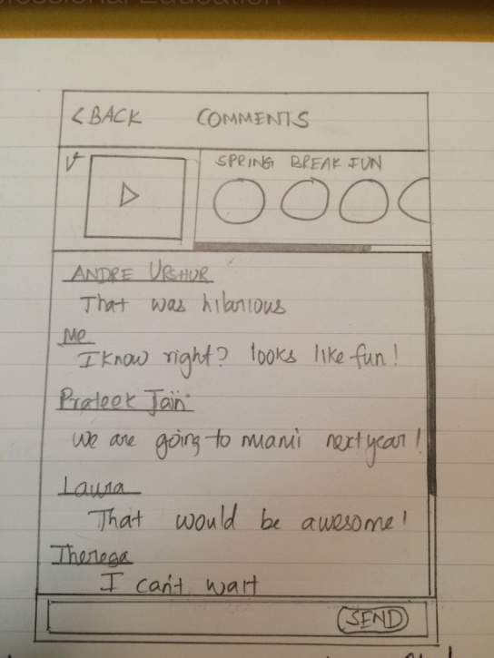

Comments

We are replacing the current chat window with this comments screen. When a user clicks on the comments button on the home screen, we will take them to this screen. This screen will have the comments that the group members has posted after viewing the content.

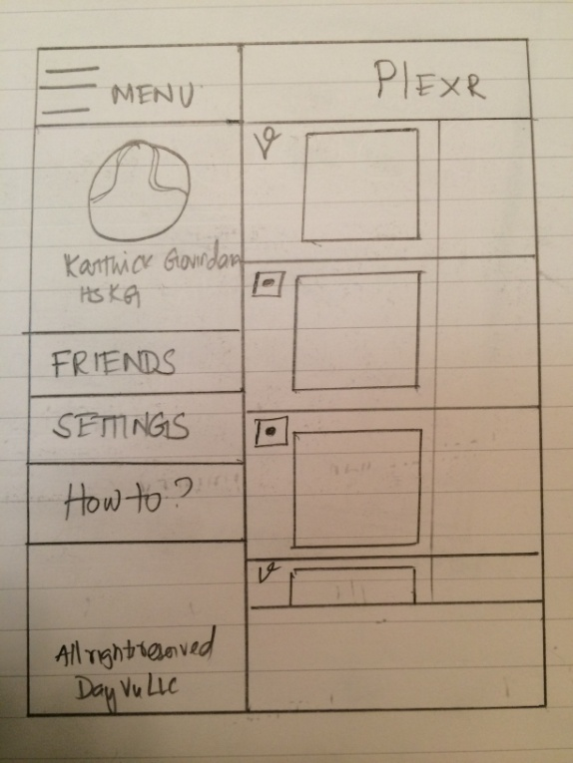

Menu

The menu will be displayed when a user taps on the menu button on the home screen. We moved the friends tab and the settings tab from the current version to the new menu.

**Sharing:**

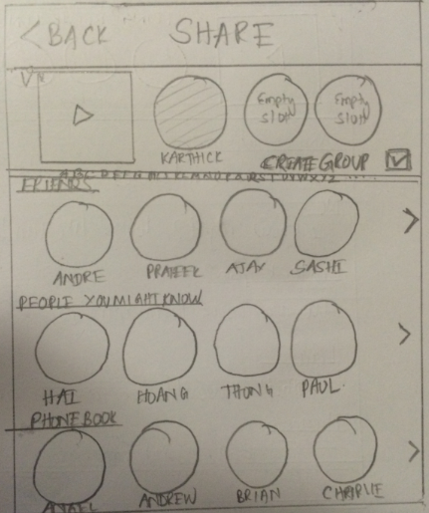

**Share screen/friends selection**

When a user chooses to share content, this is the screen where we will let the user select the friends whom they want to share the content with.

There are three rows each representing a category.

* Plexr friends
* Users in the phone book who are Plexr users but not friends.
* Phonebook ( users who are not Plexr users)

To browse through the categories, the user can scroll side to side or use the alphabets on top of the friends bar to go to a certain alphabet. If a user selects a certain alphabet, all the categories will show the contacts whose names start with that alphabet. The user can tap on the contact and it will be added to the share list which is displayed at the top of the screen right next to the thumb nail (we can also use drag and drop if we like)

The Create group check will be used by the user to pick if he/she wants to create a group or share it privately with all users. The create group will be checked by default.

If the create group is not checked the content will be shared with all the selected friends but it will be shared privately; i.e. the receivers will not know who all are in the group. The content will be displayed in the home screen in the same way as group chat, but the comments screen will be different if the group chat was not selected while sharing.

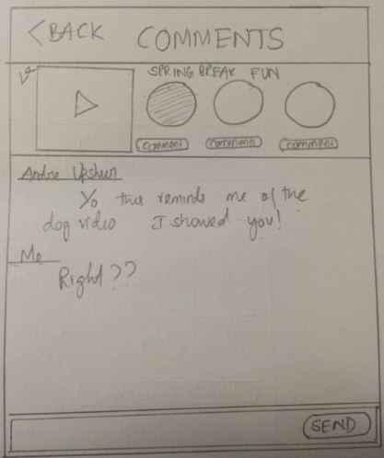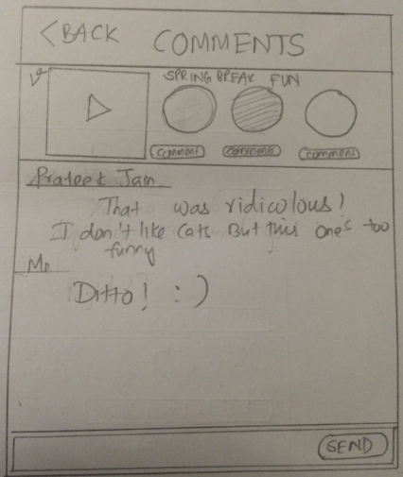

Comment: user 1 Comment: user 2

As it’s displayed, if the group chat is not enabled, in the comments section, each receiver will have a separate comments section that can be viewed by the sender. Both these screens belong to the content sender. However on the receiver’s phone the home screen and the comments screen will have only his/her thumbnail and they will be able to view only the comments posted by them and the response of the sender.